Scenario:  [A retail manager or business analyst uses a Tableau dashboard to analyze how product placement influences sales across various stores.] |   Entice  How does someone become aware of this service? |   Enter  What do people experience as they begin the process? |   Engage  In the core moments in the process, what happens? |   Exit  What do people typically experience as the process finishes? |   Extend  What happens after the experience is over?
  Experience steps  What does the person (or people) at the center of this scenario typically experience in each step? | Hears about the dashboard in a team meeting. Receives a link via company email. Gets a Slack message from manager with dashboard preview.  Watches a short demo  video. | Opens the dashboard Signs in using company 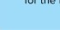for the first time. credentials.  Navigates tabs like  Sales Trends,  Placement Impact. | 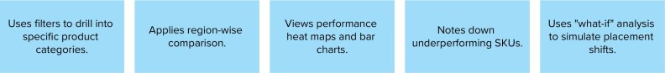 | 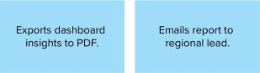  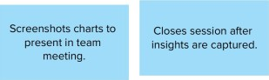 | Reviews next week's Recommends  Shares success stories  dashboard for updated dashboard  internally.  sales. improvements.
  Interactions  What interactions do they have at each step along the way?  People: Who do they see or talk to?  Places: Where are they?  Things: What digital touchpoints or physical objects do they use? | Talks with business ngages with internal Attends training analyst. email announcement. webinar.  Reads internal  Receives peer documentation Or recommendations. Confluence page. | Email from IT with Tableau login screen.  credentials.  Initial data glossary or guide. | Filters and interactive Chat with analyst for KPI cards and tooltips_ Tooltip insights on hover.  graphs in Tableau. interpretation. | Close brow'ser or return Share via Teams/SIack.  to task tracker.  Export. download. and share features. | Weekly summary email Dashboard updates Collaborative review alert. from analytics team. sessions.  Continuous access to Feedback form or email Tableau reports. suggestions.
Goals & motivations  At each step, what is a person's primary goal or motivation?  ("Help me..." or "Help me avoid...") | 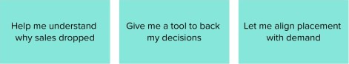 | Don't confuse me with too many tabs 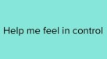 | 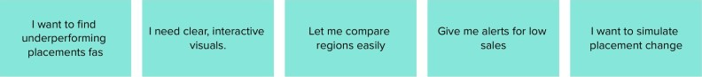 | 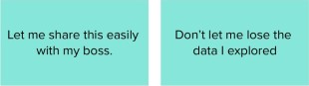 | 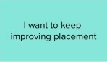 | 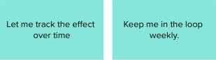
Positive moments  What steps does a typical person find enjoyable, productive, fun, motivating, delightful, or exciting? | 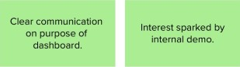 Feels confident it will help decision-making.  Sees past success stories. | Easy and smooth login process. Fast initial load time.  Clean layout and interface. | 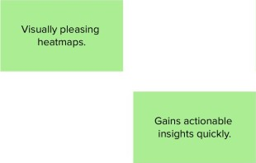 Interactive filters respond instantly. Enjoys testing "What-if" 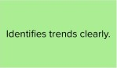 | Quick report export feature. Positive feedback from manager.  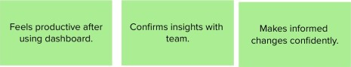 | 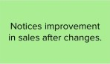 | 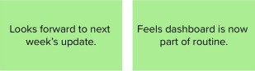  Motivated to share best practices.
Negative moments  What steps does a typical person find frustrating, confusing, angering, costly, or time-consuming? | Doesn't know where to Lacks clarity on its find dashboard. benefits initially, Fears it'll be complex.  Not engaged by email alone. Confused by internal terminology. | 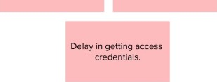  Confusing  layout  at  first.  Minor  login  bugs. | Charts feel overloaded.  Filters reset too easily.  Long loading times on Doesn't know how to large data sets. use "what-if" simulation., | Dashboard freezes during export.  NO summary page. | Lacks trend summary Needs competitor data Suggestions go over long term. that isnt available unacknowledged.
  Areas of opportunity  How might we make each step better? What ideas do we have? What have others suggested? | use internal campaigns Create short teaser Include success or champions. videos. metrics in launch email.  post banner in internal tools (Slack. intranet). | Simplify login and Provide onboarding landing page. checklist  Improve help documentation. | use Al-driven insight recommendations. Add training videos for filters/simulations. personalize views by location/role. Auto-save filter State, Improve speed on large datasets. | 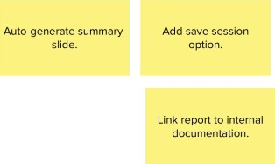  Add save session option. | Reward users with recognition badges.  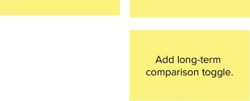  Weekly email highlights Offer dashboard usage  placement  impact  analytics,

